comp150-07 - assignment a0 - Justin Shiiba, Karl Cronburg, Susi Kharraz-Post

1. Find two visualizations
We chose two visualizations of data from the current issue of TIMES magazine. (Sept. 8 / Sept. 15, 2014 issue, US edition).
a. The visualization we liked can be found on p. 66/67 in the above
mentioned issue and gives information on various aspects of
drug use of different hallucinogenes in the US.

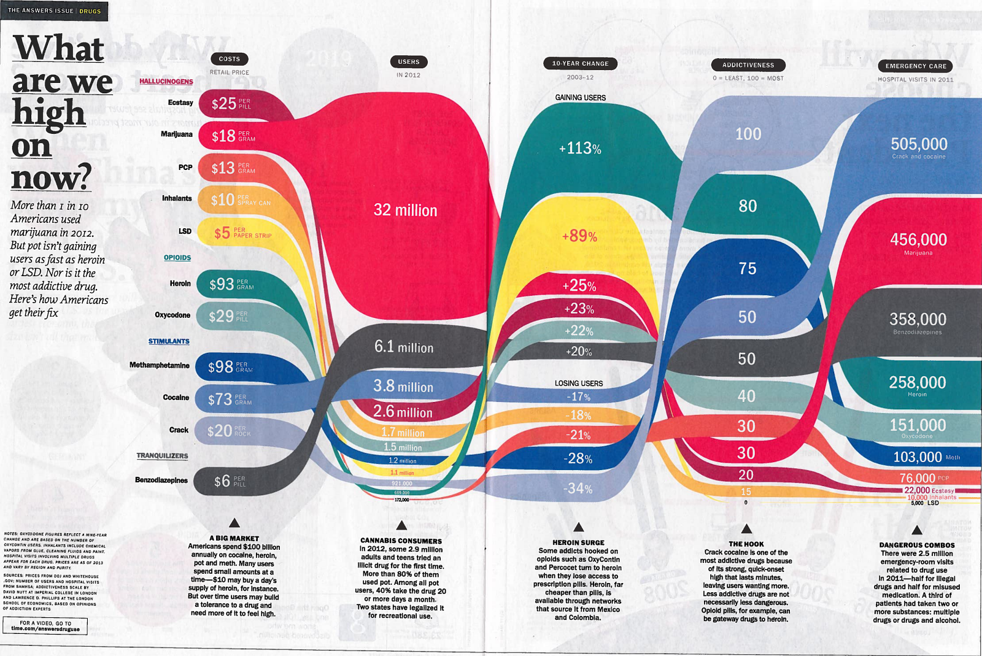
b. The visualization we didn’t like can be found on p. 70 in the
above mentioned issue and gives information on the global cash
reserves in 2013.

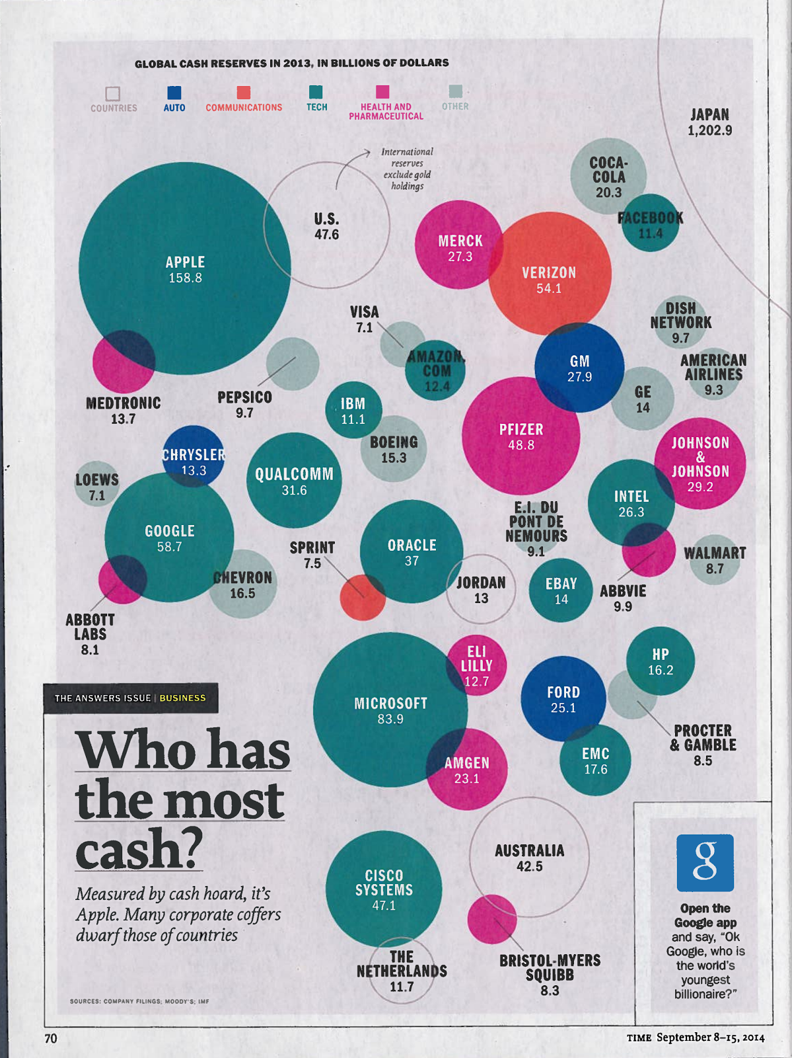

2. Visualization we liked
The visualization we liked contains data on the most popular drugs over the years 2003-2012. The data includes the current cost of the drugs, number of users in 2012, percentage of users gained over the time period, a rating of addictiveness ranging from 0 (the least) to 100, and the total number of hospital visits in 2011 caused by each drug. We liked this visualization because overall it is an aesthetically pleasing graphic that is easy to understand and represents the data in a creative way.
- The color of each drug is bright and varied, which allows the reader to easily follow one drug through the graphic and see how it compares to the other drugs in each category.
- The thickness of the different colored lines portrays how high or low the drug is in each category relative to the other drugs. This is most effectively shown in the number of users category where marijuana clearly has the most users.
- The flow from left to right from each category, such as number of users to percentage gain of users, creates a nice visual representation of the varying change in usage, popularity, and addictiveness of each drug.
We think that this graphic is an effective visualization of what the data represents because it shows interesting and surprising statistics from the data. For example, the graphic shows that some of the more recent and popular drugs, such as heroin and oxycodone, have a relatively small number of users compared to cocaine which is actually losing popularity. Facts like this are easy to interpret from the graphic and thus make the graphic successful in its visualization of the data.

3. Visualization we didn’t like
The chart we picked for this category is depicting the global cash reserves in 2013 in billions of dollars. The data is sorted into six categories, “countries” , “auto”, “communications”, “tech”, “health and pharmaceutical”, and “others”. The data is displayed as a bubble chart with overlapping circles of different colors, where each color is linked to one of the above categories.
Issues we found with this visualization are:
- There is no way to discern why some of the circles are overlapping - the legend doesn’t give an indication of what overlap means and we couldn’t find an obvious connection between e.g. Merck and Verizon. If the overlap indeed is meaningful then in our opinion having a percentage or an actual value of the overlap would be necessary to make this chart really useful. If the overlap is not meaningful, we find the arrangement of the bubbles unnecessarily confusing, as it leaves the reader wondering if there is meaning or not.
- Closely connected to the above point, we found the arrangement of the circles on the page too random - there is no apparent connection between bubbles that are in close proximity to each other.
- We thought the choice of color was somewhat unfortunate, with all distinct colors apart from categories “tech” and “other” which are two shades of green. We feel that picking different shades of the same color could be perceived as communicating that those two categories are somewhat related, which clearly they are not. We feel that picking one more color would have helped the clarity here.
- Lastly, the fact that Japan is dwarfing all other entities, so that its circle is too big to be displayed on the page, is too hidden because the color for category “country” is the background color with just a stroke line for the outline. This makes it easy to miss Japan and its dimensions on this chart.

4. Redesign of the visualization
See next page.

5. Explanation for our design
For the redesign we chose a bar chart with overlayed section totals. We feel this better organizes the data for comparison between sectors, and leaves space for textual content to give the data a better context which the original article lacks. Arranging the data along a common axis also makes it easier to compare the different entities compared to the random distribution in the bubble chart.
We also used a distinctly different color for each sector to clearly differentiate between them.
